**Developer information**

NAME:SHAHAD ALI ALSAEED

ID:381205018

EMAIL:alsaeedshahad5@gmail.com

ALJOUF UNIUVERSITY

**Description of the project**

**My project is about developing a program to help users process files.**

**Tech stack:**

1. **Java.**

**2. File Handling.**

1. **data structure.**

**Project Users Stories: Agile and Scrum**

**idea --> users’ stories**

**-> jeera --> too -> write users stories -> screen shots ->**

**1:** **As a <role> I want <feature > so that <goal>**

**2: As a user I want to know the information of the developer**

**3: As a user I want to see all the files in the folder**

**4: As a user I want to list all the files to see them**

**5: As a user I want to add new files**

**6: As a user I want to search about a file**

**7: As a user I want to delete a file**

**8: As a user I want to close the application whenever I want**

**9: As a developer I want to show to the user welcome screen**

**10: As a developer I want to let the user can add files**

**11: As a developer I want to let the user search in files**

**12: As a developer I want to let the user delete any file**

**Sprint 1 (1 week)**

**1: As a <role> I want <feature > so that <goal>**

**2: As a user I want list all the files**

**3: As a user I want to add new files**

**Sprint 2**

**1: As a user I want to delete files**

**2: As a user I want to search files**

**3: as I developer I want to Create welcome screen**

**Sprint 3**

**4: as a developer I want to let the user add new files**

**5: As a developer I want to let the user go back to the main menu**

Product Capability

This product helps users to manipulate with files by adding deleting or searching files And shows the files in ascending order

User interactions

All of interactions happened in this product showed in this use case diagram

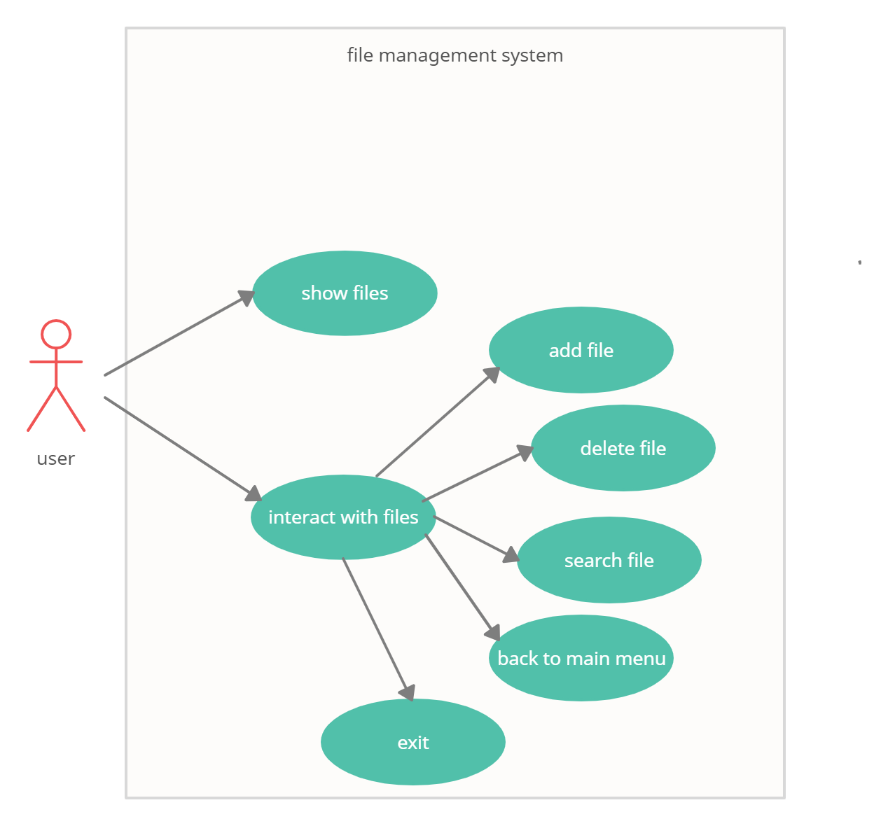

Appearance

The program will appear in the IDE console it will have small clear Font

Data Structure And Algorithm

Only one algorithm used in this program its Bubble sort to sort the file list in ascending order, Also one data structure type or kind used it’s the normal array (By normal array I meant not array list which is from java.util library

- java.util.Scanner

- java.io.file

- java.nio.file

What makes it good?

- The product provides fast accurate file manipulation

- Multi-Function

- Secure

- Easy to use

- Maintain